**Amazon Systems Manager(SSM) Resource Scheduler**

You can configure Resource Scheduler to automate the starting and stopping of Amazon EC2 Instances.

With Resource Scheduler, you can choose to automatically stop and start instances across multiple AWS Regions and multiple AWS accounts.

Only the instances with a tag matching value that you specify in your configuration are stopped or started by Resource Scheduler.

Resource Scheduler only supports EC2 Instances.

If you manually start or stop an instance that was already started or stopped by the Resource Scheduler, the scheduler will not override or revert those manual actions.

**For example:**

If the Resource Scheduler starts an instance at 9 AM according to the schedule, and you manually stop it at 10 AM, the scheduler will not start the instance again in the next scheduled start time.

Similarly, if the Resource Scheduler stops an instance at 6 PM according to the schedule, and you manually start it at 7 PM, the scheduler will not stop the instance again in the next scheduled stop time.

**How to Set-up Resource Scheduler**

Navigate to AWS Systems Manager console – Select – Quick setup – Resource Scheduler

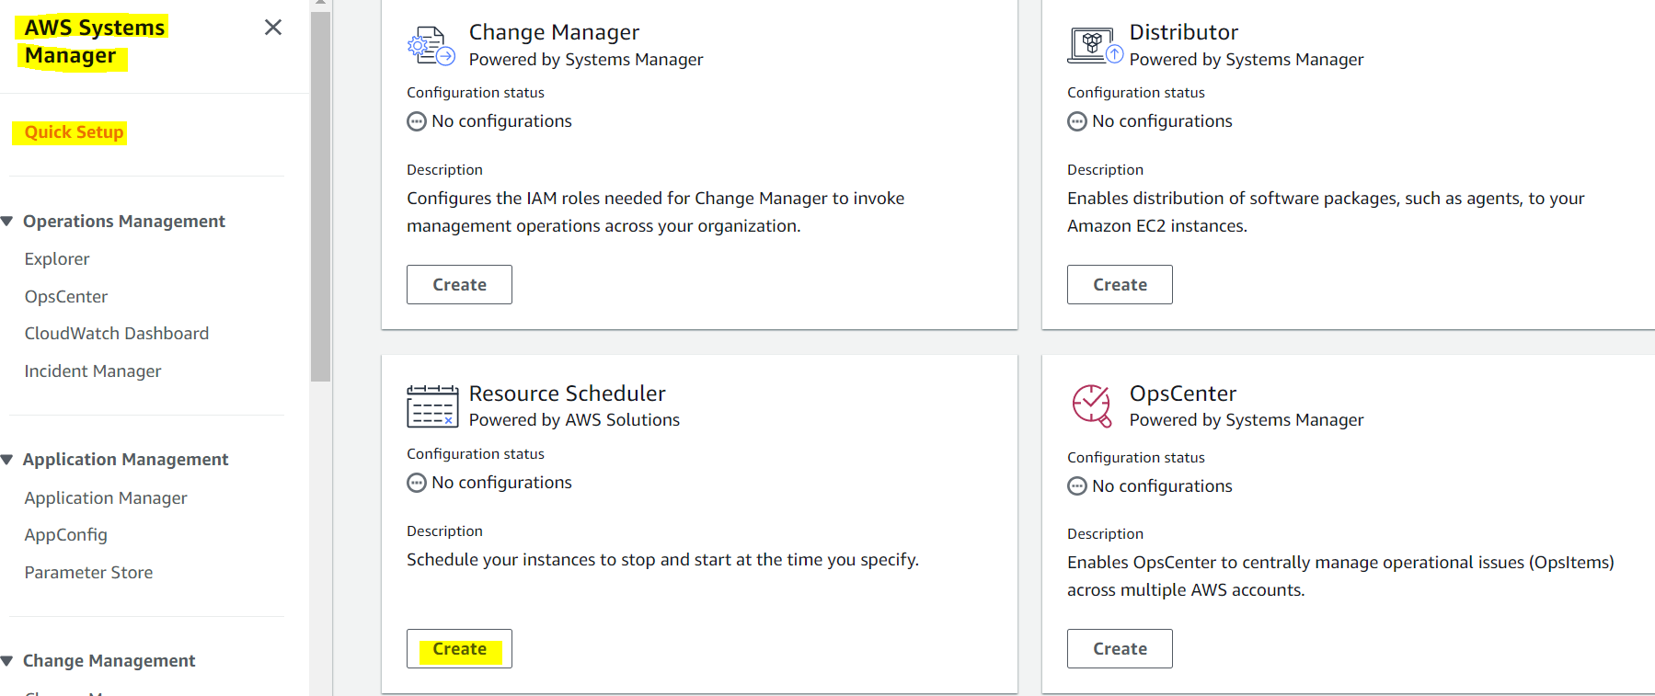

**To specify instances tags, time zone and schedule days**

**Define start and stop time for instances**

**Target Account**

Targets could be current AWS account or Custom – If you have AWS Organizations which has multiple account with OU.

**Target Regions**

Target Regions could be one or more regions

**Summary**

Finally, summary looks like

Then create the Resource Scheduler to activate.